Referencies and Copyrights
This chapter contains references to the information sources which were used to create the material.

1) IASA IT Architecture Glossary
http://www.iasahome.org/web/home/ITarchitecture/Glossary

2) Peter Eeles. Capturing Architectural Requirements
http://www.ibm.com/developerworks/rational/library/4706.html

3) Rational Unified Process (RUP) 2006

4) Minoli, Daniel. Enterprise architecture A to Z : frameworks, business process modeling, SOA, and infrastructure technology. Auerbach Publications Taylor & Francis Group. 2008. 481 pages. ISBN 978-0-8493-8517-9

5) http://www.ittoday.info/Articles/What_Is_Enterprise_Architecture.htm

There are few illustrations in the form of diagrams, tables and pictures in this document. These examples do not contain any commercial or technological information and are used only as illustrations to main ideas.

Other materials

There are some additional important materials on the sadd.codeplex.com. All the materials below are listed as we recommend them to use and how they are referenced in this document. But for better understanding you may start reading from [3], then get back to reading the current document and that read all the rest materials [1-5] in order they are mentioned in this document.

- SADD-MTHD-02-Architectural Requirements.doc – practical methods and best practices of how to develop and manage architectural requirements

- SADD-MTHD-03-Architectural Mechanism.doc – practical methods and best practices of how to design and develop architectural mechanisms

- SAAD-MTHD-04-Analysis and Modelling.ppt – presentation named «System analysis basics with the accents on roles and risks» . This presentation shows different models kinds and how to use them during SADD. There are also some theoretical and practical aspects, namely how to reduce quality achievements risks and how to distribute activities and responcibility between different project roles effectively.

- SADD-MTHD-05-Architecture Testing.doc – framowrk how to test developed architectural mechanisms with the illustration of how test case and results of such testing might be presented.

- SADD-MTHD-05-RD and AD parallel development strategy.doc – the short description of how to do parallel development of requirements and architecture in the project.

Table of Content

Referencies and Copyrights 1
Other materials 1
Table of Content 2
What is the Architecture ? 3
1. Common definition of Architecture 3
2. Enterprise Architecture 3
3. Enterprise Architecture Model 3
3.1. A Layered Model of Enterprise Architecture 4
4. Solution Architecture 4
5. System, Software and Data Architecture 5
5.1. Conclusion 5
Architecture Development Methodology 5
1. Architecture development activities 5
1.1. Perform Architectural Synthesis 7
1.1.1. Architectural Risks Elicitation 7
1.1.2. Realization Technology Decision analysis and resolution Technique 7
1.2. Define a Candidate Architecture 10
1.3. Analyze Behavior 10
1.4. Refine Architecture 11
1.5. Design Components, Design the Database, Design Services 13
1.6. Impact Analysis 16
1.7. Refine and Specifying Architecture 16
1.7.1. System Architecture Document 16
1.7.2. Software Architecture Document 16
1.7.3. System Design Specifications 16
2. Architecture Specifying 16
2.1. System Architecture Specifying 16
2.1.1. Levels of abstraction 17
2.1.2. System Architect role 18
2.1.3. System Architect artifacts 18
2.2. Software Architecture specifying 18
2.2.1. Software Architect Role 19
2.2.2. Software Architect artifacts 19
2.2.2.1. Software Architecture Document 19
2.2.2.2. System Design Specification 19

What is the Architecture ?

Common definition of Architecture

As described in ANSI/IEEE Std 1471-2000, an architecture is “the fundamental organization of a system, embodied in its components, their relationships to each other and the environment, and the principles governing its design and evolution”, where:
- fundamental organization means essential, unifying concepts and principles;
- system includes application, system, platform, system of systems, enterprise, product line, ...;
- environment is developmental, operational, programmatic, … context of the system.

Enterprise Architecture

Enterprise Architecture. High level enterprise-wide Architecture mapping business needs to IT capabilities. The focus is on defining the relationships, flows and implementation of business processes, activities, functions, information, applications, data and technology in the enterprise, and IT changes necessary for implementing technology in response to changing business needs.

Enterprise Architecture Model

Enterprise Architecture is the conjunction of Business Architecture, Information Architecture, Solution Architecture and Technology Architecture.

Below you may find out the diagram from the Minoli, Daniel book [4].
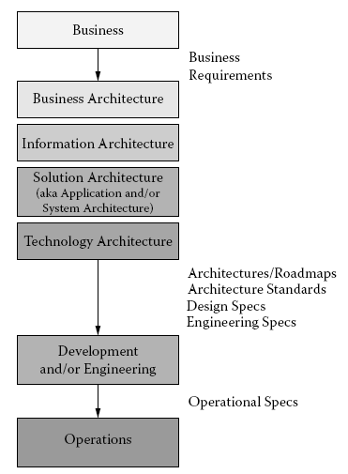
Figure 1
Business Architecture. Describes all business processes, business assets, business entities and business rules from the perspective of Business. Business Architecture does not depend on software development technologies.

Information Architecture. Determines data structures and describes all the data flows in the Business Architecture. There are such operations as identification, systematization, categorization, data storage belongs to Information Architecture. It’s often presented as Data Model.

Solution (System / Application) Architecture. The architecture of all the software family which is working as integral and indivisible system to realize Business Architecture functions.

Technology Architecture. Describes the architecture of IT-environment, which is used to deploy and to functioning of Information Architecture and Solution (System / Application) Architecture.

Different views of architecture (Business Architecture, Information Architecture, Solution Architecture и Technology Architecture) are closely related. Only the right and optimal integration and conjunction of all these architectures give the chance to build successful Enterprise architecture.

A Layered Model of Enterprise Architecture

Lets consider Enterprise Architecture from the resources used and layers to be divides on: logical resources, physical resources, and management resources.
Physical resources in the Technology Layer provide the environment and services for executing applications; these resources encompass platforms (mainframe and midrange processors) along with hardware and operating system (OS) classifications; storage; desktops; and, networks (covering eight subcomponents). The Operations and Management Layer is a combination of processes and tools required to support the entire IT environment. It covers detection of faults and outages, configuration, administrative accounting, performance, and security.

Below you may find out another diagram from Minoli, Daniel book [4].
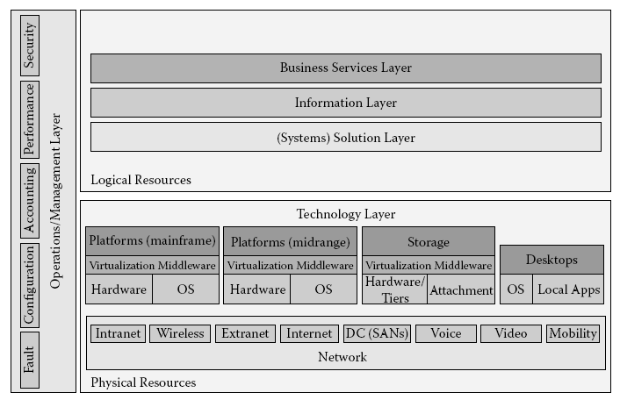
Figure 2

Solution Architecture

Solution Architecture. The architecture required to solve a business problem. It’s part of Enterprise Architecture.

System, Software and Data Architecture
System Architecture is the part of Solution Architecture.
System Architecture. There are many definitions of System Architeture, lets have a look to some of them.
The fundamental organization of a system, embodied in its components, their relationships to each other and the environment, and the principles governing its design and evolution (см. определение Software Architecture).
A set of inter-related patterns that structure modules and data and provide behaviors (см.определение Data Architecture).
A representation of a system in which there is a mapping of functionality onto hardware and software components, a mapping of the software architecture onto the hardware architecture, and human interaction with these components.

Software Architecture. Is the part of System Architecture. It describes system organization from the perspective of software components’ functionality, dependency and composition.

Data Architecture. Is the part of System Architecture. It describes data structures and logical data relationships (hierarchical model, network model, relational model, object model and etc.).

Conclusion

In SADD we made assumptions:
- Software Product consists of some Software Systems and could be compared to Enterprise Architecture by Minoli, Daniel.
- Software System Architecture corresponds to System Architecture by Minoli, Daniel. Every System consists of some Software Solutions.
- Software Solution Architecture corresponds to Software Architecture by Minoli, Daniel.

From the perspective of Software Product Evolution the Enterprise Architecture is critical.
From the perspective of Software Product Development the Software Architecture, System Architecture and Data Architecture are critical.

To define architecture of System (Software Product, Application), it is necessary to do the following:
- define scope of the System;
- define functional subsystems of the System and their scopes;
- define interfaces between subsystems;
- define data flows between subsystems;
- define interfaces with outer Systems and Software;
- define deployment requirements and scenarios in depend on Operational Systems.

Architecture Development Methodology

Spiral Architecture Driven Development (SADD) methods and actions to develop Architecture are based primarily on RUP 2006 and Spiral development methodology by Boehm. In SADD we tailored some specifications and add some diagrams to solve particular tasks.

To understand the SADD methodology from the perspective of software development project lifecycle see the SADD common description on the sadd.codeplex.com.

All the practices described below were used in real projects and placed in this document as illustrations only. There is no commercial or technical specific in them.

Architecture development activities

The main activities of System Architect are shown on the figure below.
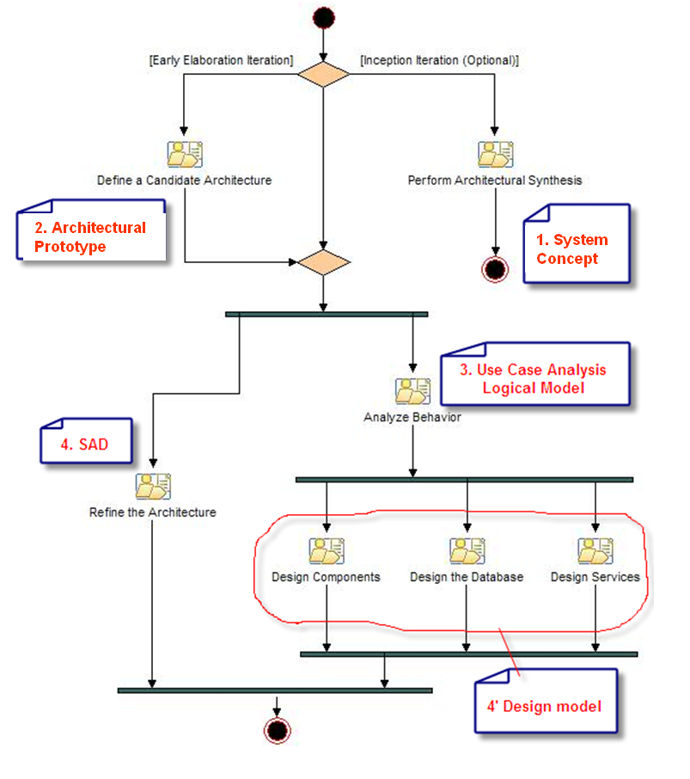
Figure 3.

Perform Architectural Synthesis

The color of specification template names background has its meaning described in the table below:

Table 1. Level of specifications
Conceptual level
System Architecture level
Software Architecture level
System Design level

The result of primarily architectural analysis is the System Vision Specification where Architect proposes basic architecture solutions.

See SADD-TPLT-01-System Vision Specification.doc to find out System Concept Specification (System Vision) Template.

Architectural Risks Elicitation

Architect is responsible for elicitation of architectural risks.

Architectural risk – is the risk of non-satisfaction the designed and implemented architecture to the quality attributes and system requirements developed.

Example
During architectural analysis in the project ZZZ the following architectural risks were elicited:
Synchronization of А and В subsystems’ databases.
Multiuser access.
Processes cooperation.

To evaluate critical level of every elicited architectural risk the system prototypes was designed and implemented. During prototype creation there was a question about realization technology to resolve. To do this we conducted decision analysis and resolution technique. (see. 1.7.1.2).

Architectural risks management is closely related to architectural requirements development and management. See «SADD-MTHD-02-Architectural Requirements.doc» for details.

Realization Technology Decision analysis and resolution Technique

To make the right choose of the realization technology we used special technique DAR (Decision Analysis and Resolution), which you may find out in the SEI CMMI v.2.0 model. We conducted a series of meetings and interviewed stakeholders with afterwards weighting answers and calculation of integral weighs for every criteria defined before discussion and analysis have been started.

In the table below you may see the illustration of the result of this process.

 |  |  | .NET FRAMEWORK |  |  |  |  | Win32API, MFC, ODBC, STL
 | Criteria description | Weight | Technology to realize | Advantages | Disadvantages | Estimation |  | Advantages | Disavantages | Estimat
Opportunities
Code development
Technological opportunities to create allpication
IPC  (interprocess communication) |  | 5 | WCF (Windows Communication Foundation) | - the prototype of Communication architectural mechanism was developed on C# and C++/CLI and tested  - easy to learn | - necessity to learn the team | 1 | DCOM, COM+, Pipes, File Mapping |  | - Complex technology  - there are no team members with enough experience | 0
Ability of ready to use components and mechanisms |  | 3 | Enterprise Library | - source codes available;  - ready to use mechanisms: Cache Management, Logging, Exception Management, DB Service, System DB Transaction, RDBM (particulary);  - free of charge;  - А. и В. are experienced in Data Access Application Block | - necessity to learn the team | 1 | STL |  |  | 0
XML support |  | 3 |  | - embedded support (there are sprcial classes to work with the XML).  - SQL Server 2005 (2008) has inner data type XML | - necessity to learn the team | 1 |  |  | - necessity to use outer libraries | 0

Common aspects of Software Development Process
Usage experience of ZZZ project and best practices in other company projects |  | 4 |  |  |  |  |  |  |  | 0 |  |  |  |  |  | 1
Easy to develop and support |  | 5 |  |  |  | - WCF;  - XML support |  |  |  | 1 |  |  |  |  |  | 0
Multi language support |  | 0 |  |  |  |  |  |  |  | 1 |  |  |  |  |  | 0
Productivity for the technology sake |  | 0 |  |  |  | are not elicited |  |  |  | 0 |  | are not elicited |  |  |  | 0
technology perspectives | 4 |  |  |  |  |  |  |  | 1 |  |  |  |  |  | 0
Experience | 5 |  |  |  |  |  |  |  | 0 |  |  |  |  |  | 1
Learning ability | 1 |  |  |  | - There are lot of information and practical examples (MSDN, books, forums) |  |  |  | 1 |  |  |  |  |  | 0

Subtotal (Common aspects of Software Development Process ) | 12 |  |  |  | 9
TOTAL  (integral estimation) | 27 |  |  |  | 17

As the automation tool the ordinary MS Excel was used.

Define a Candidate Architecture

This activity has the following goals:
Create an initial sketch of the architecture of the system
Define an initial set of architecturally significant elements to use as the basis for analysis
Define an initial set of analysis mechanisms
Define the initial layering and organization of the system
Define the use-case realizations to be addressed in the current iteration
Identify analysis classes from the architecturally significant use cases
Update the use-case realizations with analysis class interactions

The Figure 5 shows the faced off diagram of Candidate Architecture of the ZZZ project. The main purpose of this diagram is to show the main components and data sources, they working with or communication through.

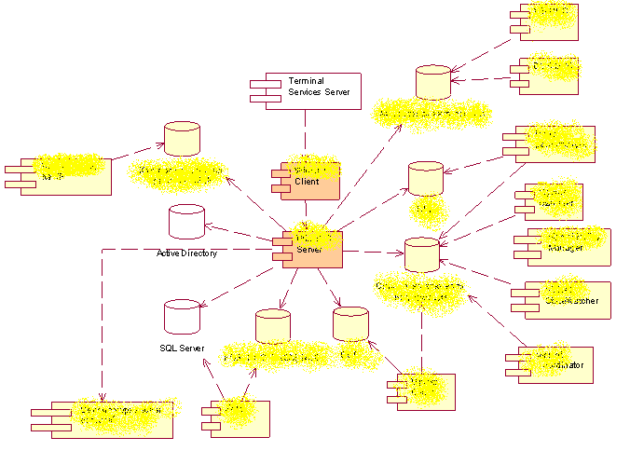
Figure 5.

Defining a Candidate Architecture includes also creation architectural prototypes to be sure in rightness of the architectural decisions.

In the ZZZ project there were implemented architectural prototypes:
- Architectural prototype of client-server interconnection based on Windows Workflow Foundation (WWF) Communication;
- Architectural prototype of native-code usage (P\Invoke, COM Interop).

Analyze Behavior

This activity occurs in each iteration in which there are behavioral requirements to be analyzed and designed.
The analysis of behavioral requirements includes the following:
- identifying analysis classes that satisfy the required behavior
- determining how these analysis classes fit into the logical architecture (the major subsystems and classes) of the system. The analysis classes may be determined to belong to existing subsystems, require the creation of new subsystems, or cause existing subsystems and their interfaces to be redefined.
This activity may also include modeling and prototyping of the user interface.

Develop an Analysis-level Use-Case Realization from a Use-Case.

Below you may see the sequence diagram which is use case realization for the “Send message” use case.

Send message - Basic Flow Detailed

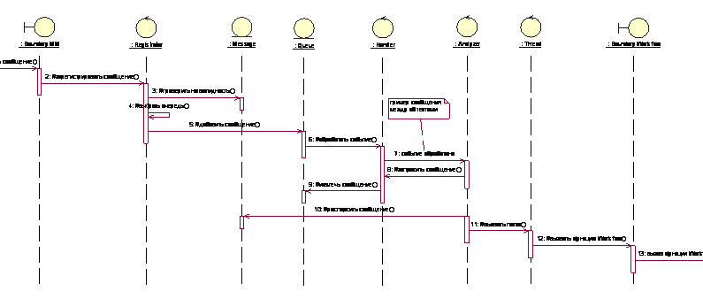

Figure 6.

Refine Architecture

This activity:
Provides the natural transition from analysis activities to design activities, identifying:
appropriate design elements from analysis elements
appropriate design mechanisms from related analysis mechanisms
Describes the organization of the system's run-time and deployment architecture
Organizes the implementation model so as to make the transition between design and implementation seamless
Maintains the consistency and integrity of the architecture, ensuring that:
- new design elements identified for the current iteration are integrated with pre-existing design elements.
- maximal re-use of available components and design elements is achieved as early as possible in the design effort.

ZZZ project Deployment Model:
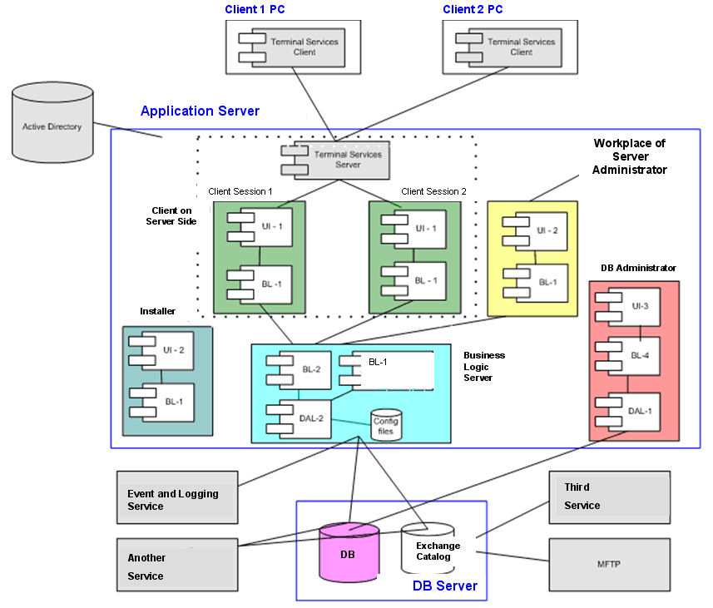

Also the modules interaction model was created:
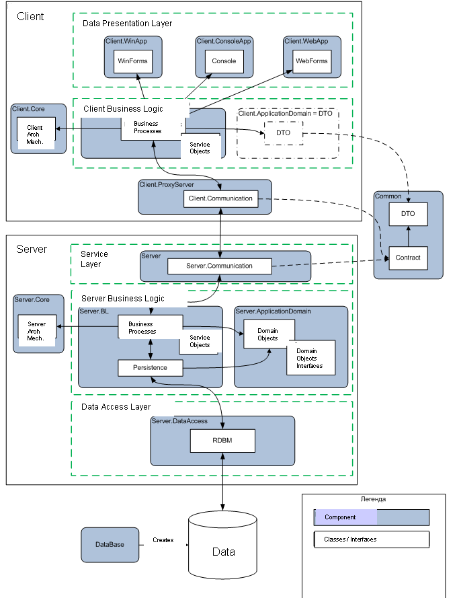

Design Components, Design the Database, Design Services

These activities started from the elicitation of the architectural mechanisms and brainstorming their realization and design. Have a look at SADD-MTHD-03-Architectural Mechanism.doc.

After architectural mechanisms had been analyzed the detailed specification of every Architectural Mechanisms (AM) was created:
For example, see SADD-TPLT-02-AM RDBM Design Specification.doc

While architectural mechanisms were implemented they were tested. (see. SADD-MTHD-05-Architecture Testing.doc)

Component model looks like:

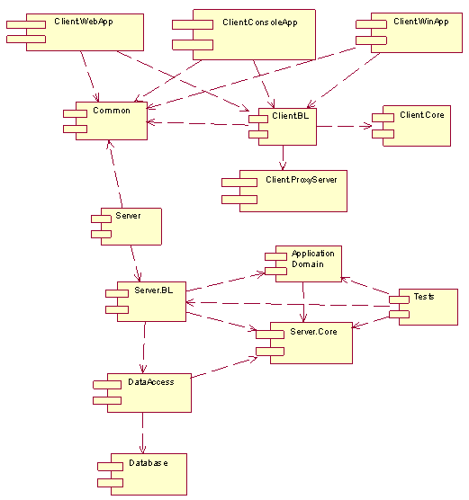
Data model looks like:

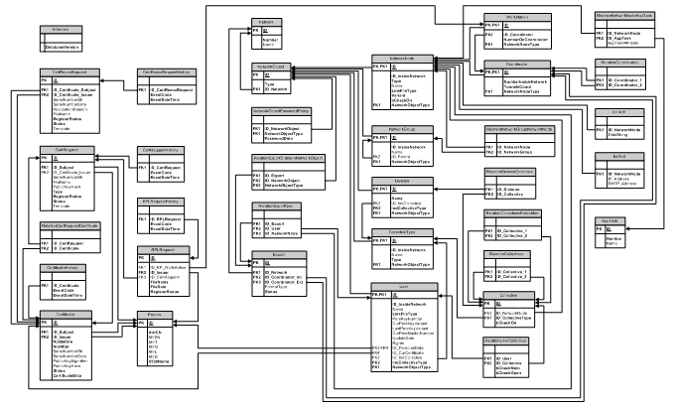
As an addition to the data model there was data specification, which described tables in the form:

Department
This table is intended to store in the Data Base information about the company departments.
Field Name | Attribute | Field type  (ANSI/ISO) | Description
ID | obligatory, unique | INTEGER | Primary key. Table record identificator.
Name | obligatory | NCHAR  ( 255 ) | Department name.
IDDepartmentType | obligatory | INTEGER | Foreign key to the DepartmentType table with the types of departments.
Script to create table on ANSI/ISO SQL99:
CREATE TABLE [Department]
(
[ID] INTEGER NOT NULL PRIMARY KEY
ON UPDATE NO ACTION
ON DELETE NO ACTION,
[Name] NCHAR VARYING( 255 ) NOT NULL,
[IDDepartmentType] INTEGER NOT NULL REFERENCES [DepartmentType]
ON UPDATE NO ACTION
ON DELETE NO ACTION
);

We recommend you learning more about different models and diagrams used in SADD in «SADD-MTHD-04-Analysis and Modelling.ppt».Besides models you will find out there which activities are responsibilities of what roles and how to manage software development risks.

Impact Analysis
In parallel with architecture development there was requirements development process. It’s critical to perform impact analysis every time when requirement is changed or new requirement is elicited. This activity is done by system analyst and system architect together.

To know how to realize paralled development of architecture and requirements, please, pay attention to the «SADD-MTHD-05-RD and AD parallel development strategy.doc».

Refine and Specifying Architecture

All the developed architectural requirements, models, assumptions and constraints were finally refined and specified in the Architectural Specifications (listed as were being created): System Architecture Document, Software Architecture Document, System Design Specifications.

The color of specification template names background has its meaning described in the table below:

Table 1. Level of specifications
Conceptual level
System Architecture level
Software Architecture level
System Design level

System Architecture Document
SADD-TPLT-03-System Architecture Document.doc

Software Architecture Document
SADD-TPLT-04-Software Architecture Document.doc

System Design Specifications
SADD-TPLT-05-System Design Specification.doc

Architecture Specifying

This charter describes RUP recommendations how to specify process both System and Software architecture.

System Architecture Specifying
The system architecture is a representation of a system in which there is a mapping of functionality onto hardware and software components, a mapping of the software architecture onto the hardware architecture, and human interaction with these components

System Architecture представляет собой переход от системного анализа к более высокоуровневому анализу.

A viewpoint (on a system) is "a form of abstraction achieved using a selected set of architectural concepts and structuring rules, in order to focus on particular concerns within a system" [ISO/IEC 10746-2: Information Technology - Open Distributed Processing - Reference Model: Foundations].
The table lists some of the viewpoints chosen to capture the various concerns. These viewpoints are aligned with those found in ISO/IEC 10746-1: Information technology - Open Distributed Processing - Reference Model: Overview.
Common System Viewpoints.
Viewpoint | Concern | Impact
Worker | Concerned with the roles and responsibilities of the organization and system workers (and the policies affecting these). | Worker activities, human/system interaction. Human performance specification and human factors.
Information | The kinds of information handled by the system and constraints on the use and interpretation of that information. | Information integrity, capacity limitations.  Information accessibility, timeliness.
Logical | The decomposition of the system into a set of subsystems that interact at interfaces, collaborating to provide the system services. | System exhibits desired behavior.  System is extendible, adaptable, maintainable.  Assets are reusable.
Distribution/Physical | The infrastructure required to support system functionality and distribution. | Adequacy of physical characteristics of system to host functionality and meet non-functional requirements.
Process | Concurrency, scalability, performance, throughput, reliability. | Adequacy of system responsiveness, throughput, fault-tolerance.
Many system architectures also require additional, domain-specific viewpoints. Examples include safety, security, and mechanical viewpoints. Viewpoints represent different areas of concern that must be addressed in the system architecture and design.

Levels of abstraction
In addition to viewpoints, a system architecture requires levels of specification. As the architecture is developed, it evolves from a general, abstract specification to a more specific, detailed specification. RUP identifies four architectural levels, as shown in the table below.
RUP Architectural Levels
Model Level | Expresses
Context | The system and its actors.
Analysis | Initial partitioning of the system to establish the conceptual approach.
Design | Realization of the Analysis Model to hardware, software, and people.
Implementation | Realization of the Design Model into specific configurations.
Through these levels, the design goes from the abstract to the physical.
The Context Model captures all of the external entities (actors) that interact with the system. These actors might be external to the enterprise that deploys the system or might be internal to the enterprise. In both cases, the actors might be human workers or other systems.
At the Analysis level, the partitions do not reflect choices of hardware, software, and people. Instead, they reflect design approaches for dividing up what the system needs to do and how the effort must be distributed.
At the Design level, the decisions are made as to the sorts of hardware and software components and worker roles that are needed.
At the Implementation level, specific choices of hardware and software technology are made to implement the design. For example, at the Design level, a data server might be specified. At the Implementation level, the decision is made to use a specific platform running a specific database application.

System Architect role
The System Architect establishes and refines the system's logical and physical structure and is concerned with the optimization of these structures in terms of major system elements and their interfaces, and making trade-offs in competing factors and constraints (for example, performance, cost, environmental impact), in evaluating potential solutions that produce the required behavior. The System Architects' view spans the entire system and all factors, external and internal, that might affect its development.

System Architect artifacts
SADD-TPLT-03-System Architecture Document.doc

Software Architecture specifying

In the RUP, the architecture of a software system is the organization or structure of the system's significant components interacting through interfaces, with components composed of successively smaller components and interfaces.
The software architecture can be represented in multiple architectural views. Each architectural view addresses some specific set of concerns, specific to stakeholders in the development process: users, designers, managers, system engineers, maintainers, and so on.
Architecture is represented by a number of different architectural views, which in their essence are extracts illustrating the "architecturally significant" elements of the models. "4+1 view model" is composed of:
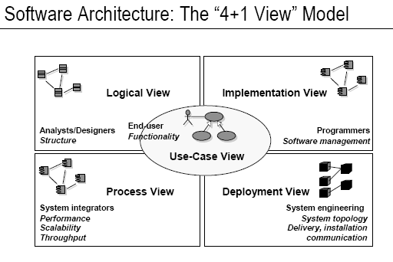
The Use-Case View, which contains use cases and scenarios that encompasses architecturally significant behavior, classes, or technical risks. It is a subset of the Use-Case Model.
The Logical View, which contains the most important design classes and their organization into packages and subsystems, and the organization of these packages and subsystems into layers. It contains also some use case realizations. It is a subset of the Design Model.
The Implementation View, which contains an overview of the Implementation Model and its organization in terms of modules into packages and layers. The allocation of packages and classes (from the Logical View) to the packages and modules of the Implementation View is also described. It is a subset of the Implementation Model.
The Process View, which contains the description of the tasks (process and threads) involved, their interactions and configurations, and the allocation of design objects and classes to tasks. This view need only be used if the system has a significant degree of Concurrency. In RUP, it is a subset of the Design Model.
The Deployment View, which contains the description of the various physical nodes for the most typical platform configurations, and the allocation of tasks (from the Process View) to the physical nodes. This view need only be used if the system is distributed. It is a subset of the Deployment Model.
The architectural views are documented in a Software Architecture Document.

Software Architect Role
The software architect has overall responsibility for driving the major technical decisions, expressed as the software architecture. This typically includes identifying and documenting the architecturally significant aspects of the system, including requirements, design, implementation, and deployment "views" of the system.

Software Architect artifacts

Software Architecture Document
The software architecture document provides a comprehensive overview of the architecture of the software system. It serves as a communication medium between the software architect and other project team members regarding architecturally significant decisions which have been made on the project. See SADD-TPLT-04-Software Architecture Document.doc

System Design Specification
See SADD-TPLT-05-System Design Specification.doc

